FIRST NAME LAST NAME

Emergency Contact: Name, relationship, phone number, email

Summey Itinerary
July 29th -
- Flight from Vienna, Austria to Dubrovnik, Croatia
- Check-in to residence: Adriatic Apartments
  - Address: Petra Kresimira 16, Ploce, 20000 Dubrovnik, Croatia
  - Phone +385 98 285 665
July 30th -
- Morning
  - Walking the City Walls
    - Minsceta’s Fort
    - Luke’s Tower
    - Fort Bokar
    - Fort Lawrence
  - Exploring Old Town
- Afternoon
  - Revelin Fort
  - Trip to Franciscan Monastery
  - Dubrovnik Cathedral
July 31st -
- Morning
  - Rector’s Palace
  - Sponza Palace
- Afternoon
  - Church of Saint Blaise
  - Dubrovnik Synagogue
August 1st -
- Morning
  - Ethnographic Museum
  - Maritime Museum
  - Bukovac House
- Afternoon
  - Komarda Rock Beach
  - Betina Cave Beach
August 2nd -
- Morning
  - Fort Lovrijenac Visit
- Afternoon
  - Flight from Dubrovnik, Croatia to Berlin, Germany
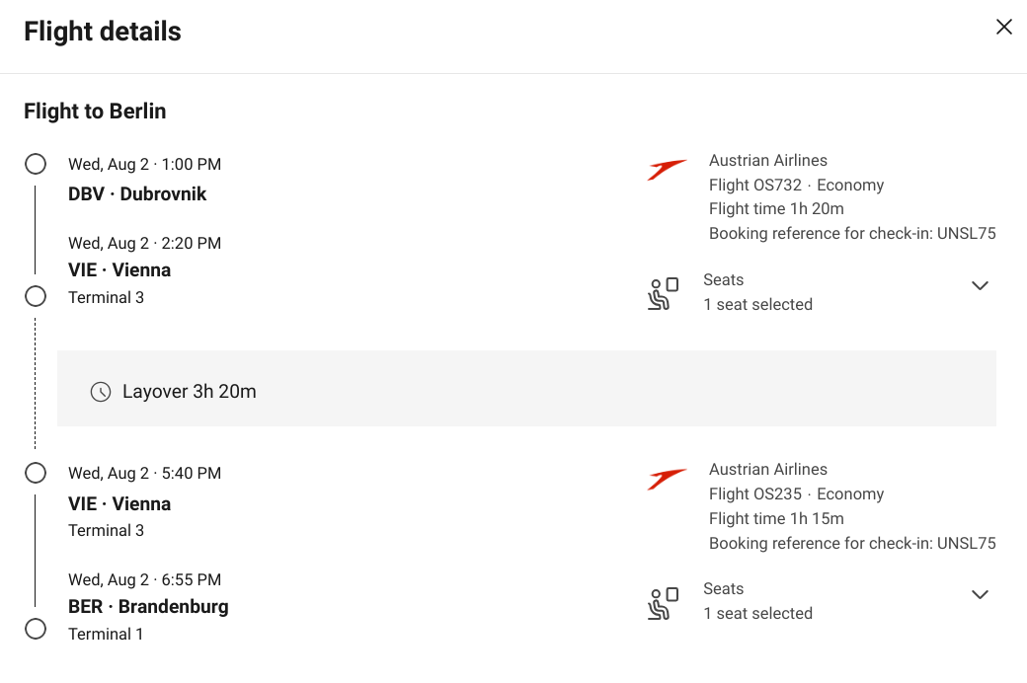
  - Metro line from Airport to Hotel
  - Check-in to residence
    - Motel One Berlin-Hauptbahnhof
    - Invalidenstraße 54, Mitte, 10557 Berlin, Germany
    - Phone +49 30 36410050
August 3rd -
- Morning
  - Brandenburg Gate
  - Reichstag Building visit
- Afternoon
  - Berlin Wall Memorial and Museum
August 4th -
- Morning
  - Museum Island Visit
    - Pergamon Museum
    - Bodes Museum
    - Neues Museum
    - Altes Nationalgalerie
    - Altes Museum
- Afternoon
  - East Side Gallery
August 5th -
- Morning
  - Jewish Museum Berlin
  - Checkpoint Charlie
- Afternoon
  - Charlottenburg Palace
August 6th -
- Flight from Berlin, Germany to NC
  - AA 2764 – BER to RDU

